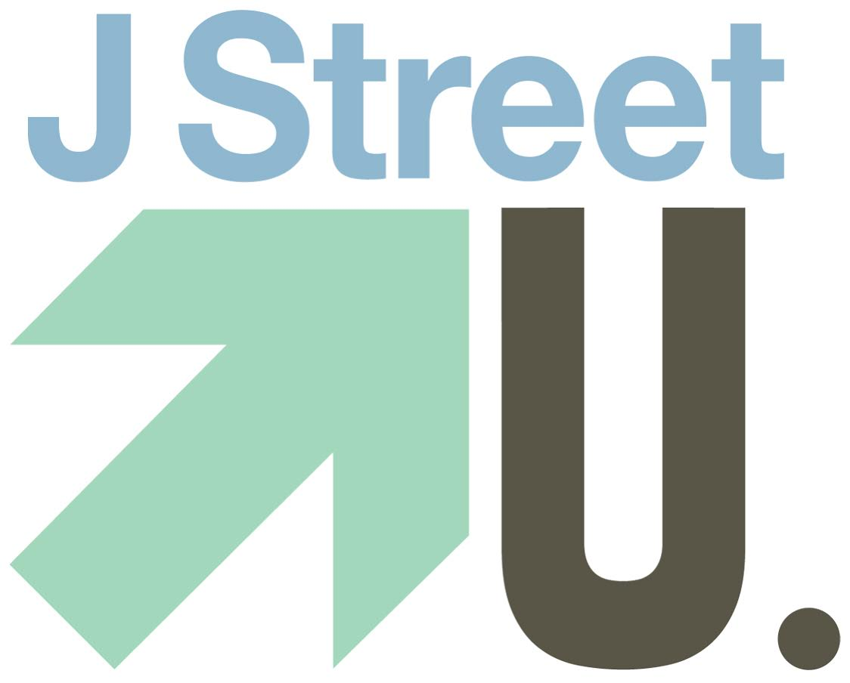

March 23, 2015

Mr. Eric Fingerhut
President and Chief Executive Officer
Hillel International
800 Eighth Street, NW
Washington, DC 20001

Dear Mr. Fingerhut,

Over the past two weeks, we have heard from you and from Hillel International that a “broad consensus of stakeholders” prevented you from speaking with over 1,000 pro-Israel, pro-peace students in attendance at the J Street National Conference.

Despite being an integral part of the Jewish and pro-Israel communities on campus, and despite our tireless work to ensure Israel’s future, you were still unwilling to publicly engage with us at our conference.

Sadly, we must ask: who is Hillel meant to serve? A small group of donors, or the thousands of students who are the future of our communities?

Despite hearing that J Street U students are an important part of the Hillel community, we believe that actions speak louder than words. Now is the time for such action.

If you are ready to engage with us in a serious way, we ask that you set up an on-the-record meeting between the J Street U National Student Board and Hillel International’s Board of Directors before the start of the 2015-2016 academic year.

We leave Washington on Tuesday afternoon. We ask that you let us know before then whether you will convene a meeting between the J Street U National Student Board and Hillel International’s Board of Directors to help ensure that Hillel’s priority is engaging seriously with students, or whether you will not help convene a meeting for Board Members and donors of Hillel to develop deeper relationships with the students that make up the Hillel community.

A delegation of J Street U leaders will return tomorrow (Tuesday) at 2:00pm to receive your response.

Respectfully,

___________________________________ ___________________________________
Name School

J Street U 

